White Oak River Chapter of the Izaak Walton League of America
2nd Annual Wild Game and Seafood Cookoff
Rules and Guidelines

The 2nd Annual Wild Game and Seafood Cookoff is a celebration of the game animals, game birds, game fish and sea life that can be harvested and utilized for food. We are also celebrating the people who harvest and utilize this wild game and seafood to feed their family, friends and customers. This event also serves as a fundraiser for our organization so we can continue our mission of promoting the enjoyment of outdoor recreation and preserving our
beautiful surroundings for future generations to enjoy.

- Entry fee is $20 per dish. You may enter more than one dish, but you must have someone available to serve each of your dishes. You must register online for each dish separately, (or fill out a separate form for each dish entered) as well as pay the $20 fee for each separate dish.

- Dishes are to be prepared off-site and brought to the Cookoff ready to serve from a device to keep it warm such as a chafing dish and Sterno setup, or a crockpot, Dutch oven or electric skillet. There are limited spaces with electricity, so please apply early if you will need electricity.

- If you will be using a chafing dish and Sterno, please make sure your Sterno cans do not sit on the table surface and are raised like the setup in the picture below.

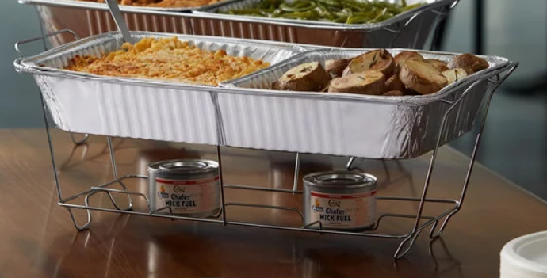

- Please be prepared to serve up to 100+ people a small 2-ounce portion of your dish. The 2oz portion cups will be provided at your table and will have your entry # written on them.

- Please bring any utensils needed to serve your dish in the 2oz portion cups, as well as any complimentary condiments.

- Entrants are strongly encouraged to utilize game or seafood that they have harvested themselves or at least have been harvested by other hunters and anglers. However, use of fish, fowl, or game species that are also commercially available is acceptable.

- We encourage you to keep it as local as possible but realize in order to keep a variety, you may need to utilize a harvest outside of the state of North Carolina. Therefore, exotic game from distant hunting or fishing trips is acceptable. If harvested outside of North Carolina or not a North Carolina species, please note on the entry form.

- We ask that the wild game or seafood in your entry be harvested legally in the past 12 months.

- White Oak River IWLA does NOT condone the harvesting or preparation of any wild game or seafood entry that is protected by the Endangered Species Act. If you have any questions regarding your proposed entry, please contact Amy Somers at 252-725-0724 prior to the competition.

- If you would like to be highlighted during the event for using numerous local ingredients, please fill out the Local Ingredient Recognition Form. We will announce these forms throughout the event highlighting your efforts, your business (if applicable) and the local businesses where you purchased the ingredients.

- You may arrive with your entry dish just after 5:00pm but no later than 5:45pm to be included in the voting. There will be a quick meeting at 5:45pm before the tasting starts at 6:00pm.

- You will have half of one 6ft. table to present your entry and decorate. It will hold the sign with your entry #. The 2oz portion cups with your entry # written on them will also be on your table.

- A “Best Presentation” trophy will be awarded to the entry with the best decorations and presentation for their table that reflects the atmosphere of a Wild Game and Seafood Cook-Off. This award will be judged on effort, creativity, and originality.

- We encourage entrants to also use their space to advertise their business, by providing brochures, coupons, etc. Each Taster will have a goody bag to collect information about your business if you wish to have a handout for them to take home with them.

- White Oak River IWLA is a tax exempt 501(c) (3) organization. As such, we cannot endorse candidates for political office or participate in/endorse electioneering of any kind so please refrain from promoting your participation in any upcoming election at your table.

- We will provide a platter to hold the tasting portion cups and a spoon for each participant that will be tasting and voting. The ballot form will ask the Tasters to list their top three choices by putting a 1, 2, and 3 by those choices. Entries that are awarded a “1” will be given 5 points. Entries that are awarded a “2” will be given 3 points. Entries that are awarded a “3” will be given 1 point.

- Tasting will begin at 6:00pm and end at 8:00pm, or earlier if all tasters have turned in their voting sheets. Votes will be tallied immediately. The entry with the highest number of points will be given a 1st place trophy. The entry with the next highest number of points will be given a 2nd place trophy and the entry with the next highest number of points will be given a 3rd place trophy.

- In the event of a tie, the Board of Directors and/or members of the White Oak River Chapter of IWLA that are present at the event will taste the entries that are tied and vote to determine the winner of that place.

- The winners will be announced at 8:30pm or earlier. After winners are announced, the floor will be open for feasting.

- Each entrant is encouraged to try and sell 5 tasting tickets to the event. Invite your friends and family members and your customers!

- If you have any questions at all, please do not hesitate to call or text Amy Somers at 252-725-0724 or email at whiteoakriveriwla@gmail.com.

